**SportyShoes Admin application**

**Developed by: Esmaeeil Enani.**

**Contact INFO:**

**Email:** [**esmaeeilenani@gmail.com**](mailto:esmaeeilenani@gmail.com)

**Github of this project:** [**https://github.com/Esmaeeilenani/SDA-LockedMe**](https://github.com/Esmaeeilenani/SDA-LockedMe)

**Discription:**

This LockedMe system is a software that can help the user to tack its own files of a specified directoryand has the following features:

* Listing all files and directory of specified directory
* Add new file to a specified directory.
* Delete a file from a specified directory.
* Search for a file in a specified directory.

**Sprint Planning:**

In this project I planed for three sprints to deliver the prototype.

1. Main Menu and first choice of selection.
2. Submenu and exit options.
3. All submenu function implementation.

**Flow Chart:**

Demonstrate the workflow of this project.

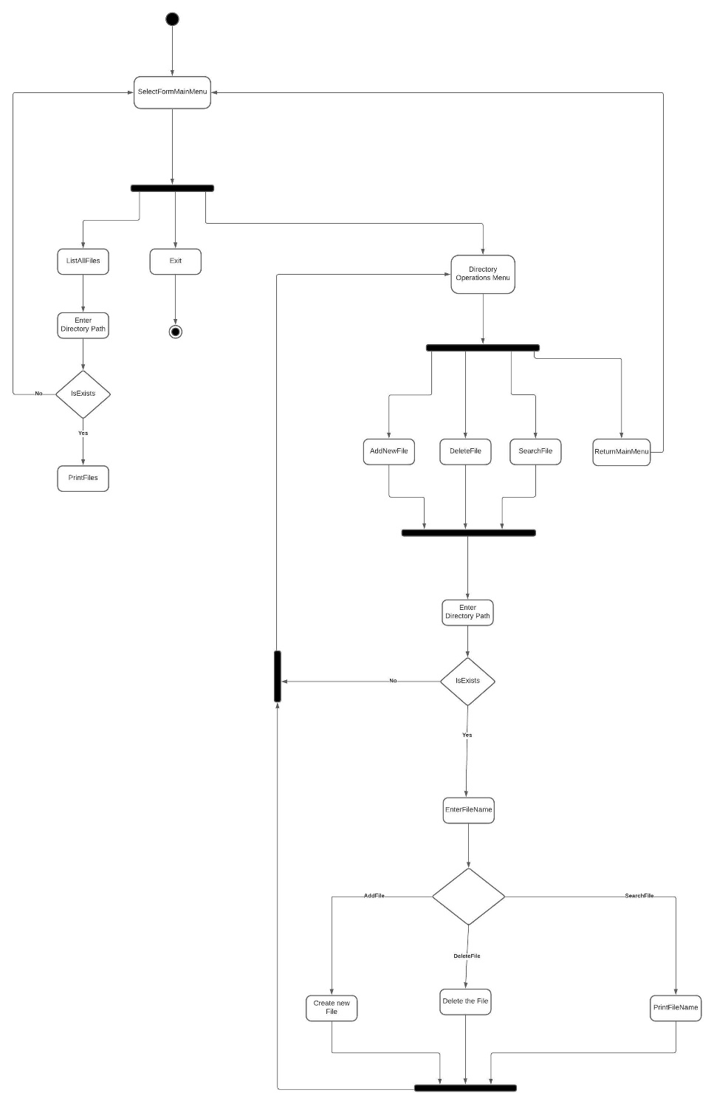

**Conclusion:**

In conclusion this project is to give the user the ability to track his own files and directory, this system can be enhanced by adding GUI (Graphical User Interface), tracking the previous searching and deletion, different sorting criteria, and writing on creation of a file.